* Register this as a new application
* 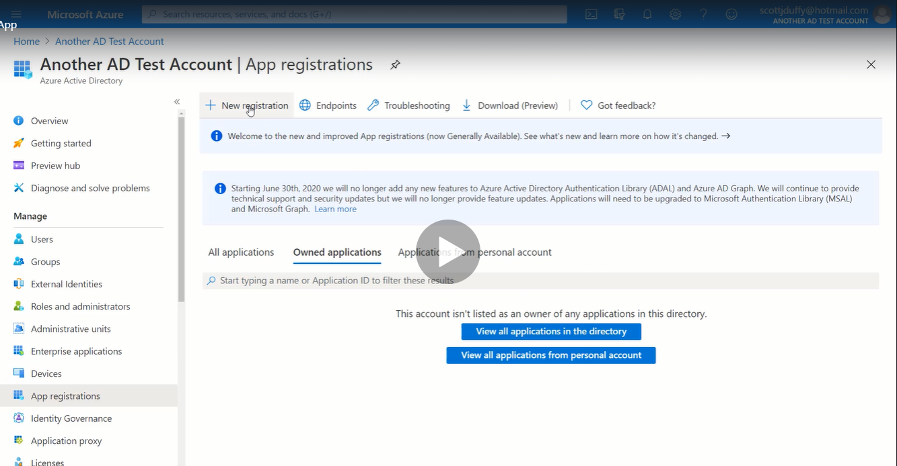
* Follow this https://docs.microsoft.com/en-us/azure/active-directory/develop/quickstart-v2-aspnet-webapp